**Name:** Syed Ibn E Abbas

**Task:**

1. **Firebase authentication (Twitter)**

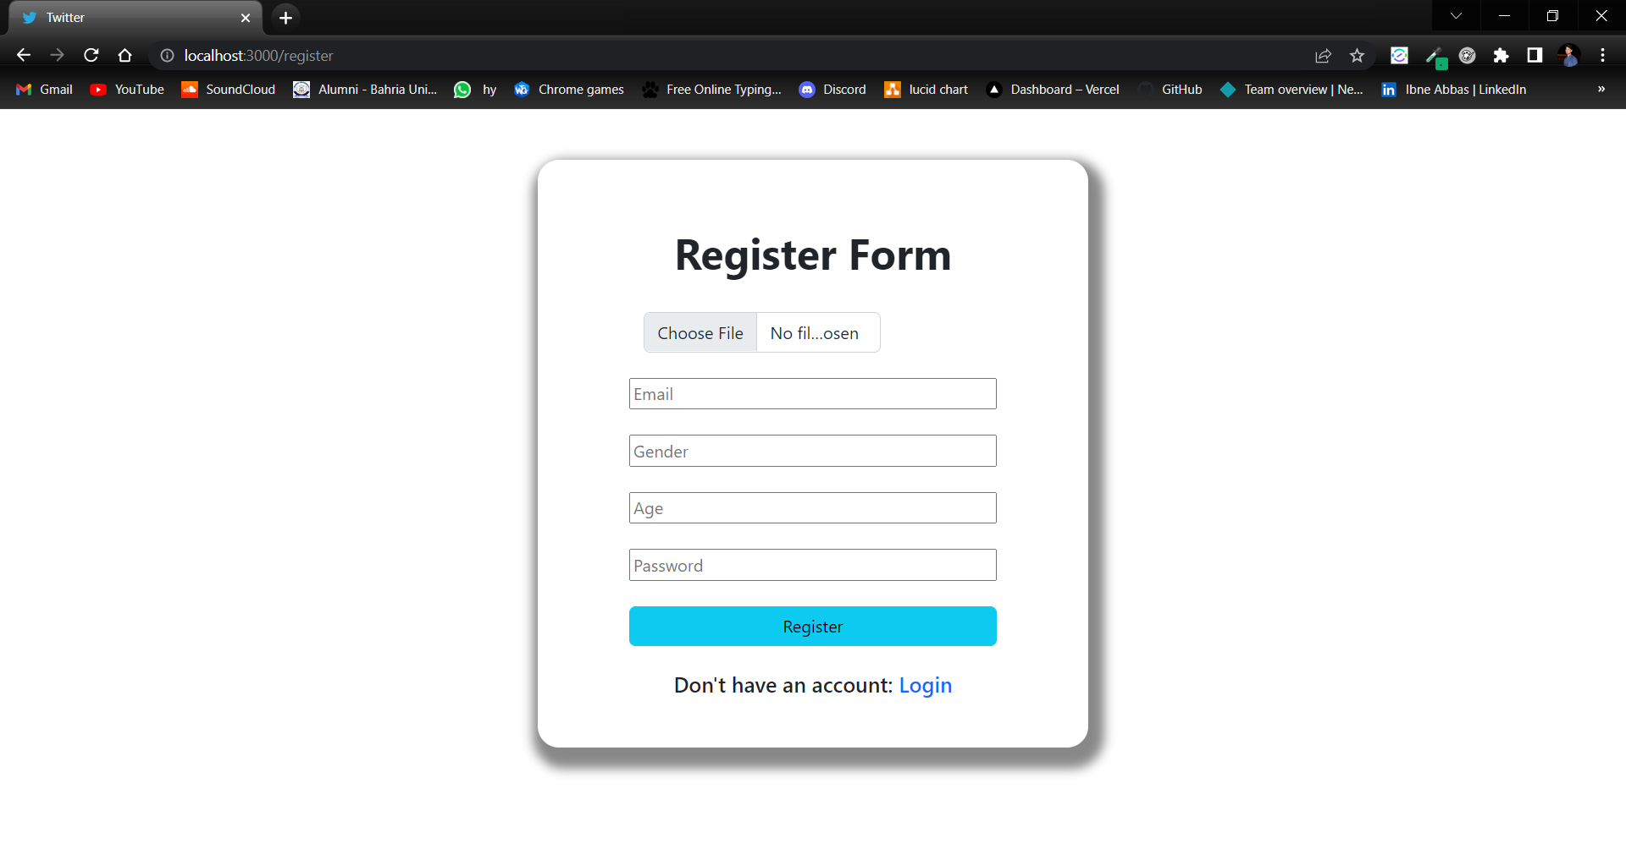

* Using Email and Password Authentication is done in firebase.
* The data such as gender, age, email and password is stored in the data base while user registered himself.

1. **Data (Profile pic, email, posts, friends, Gender, age)**

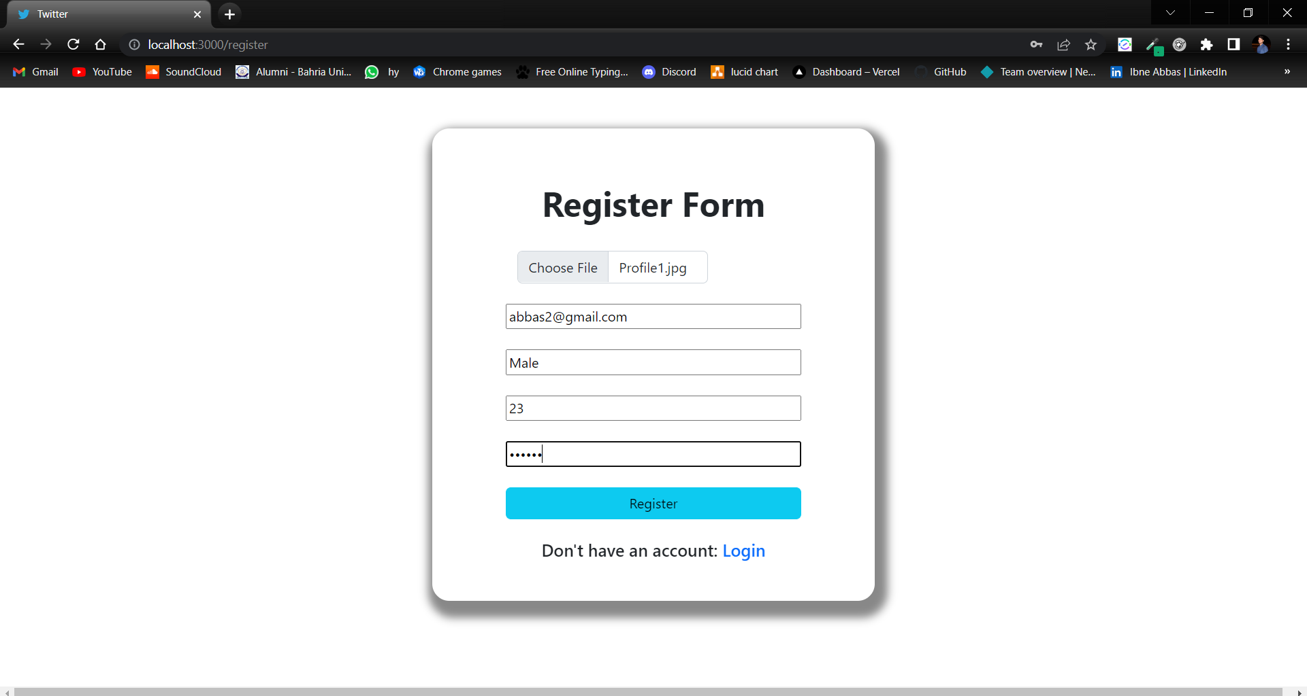

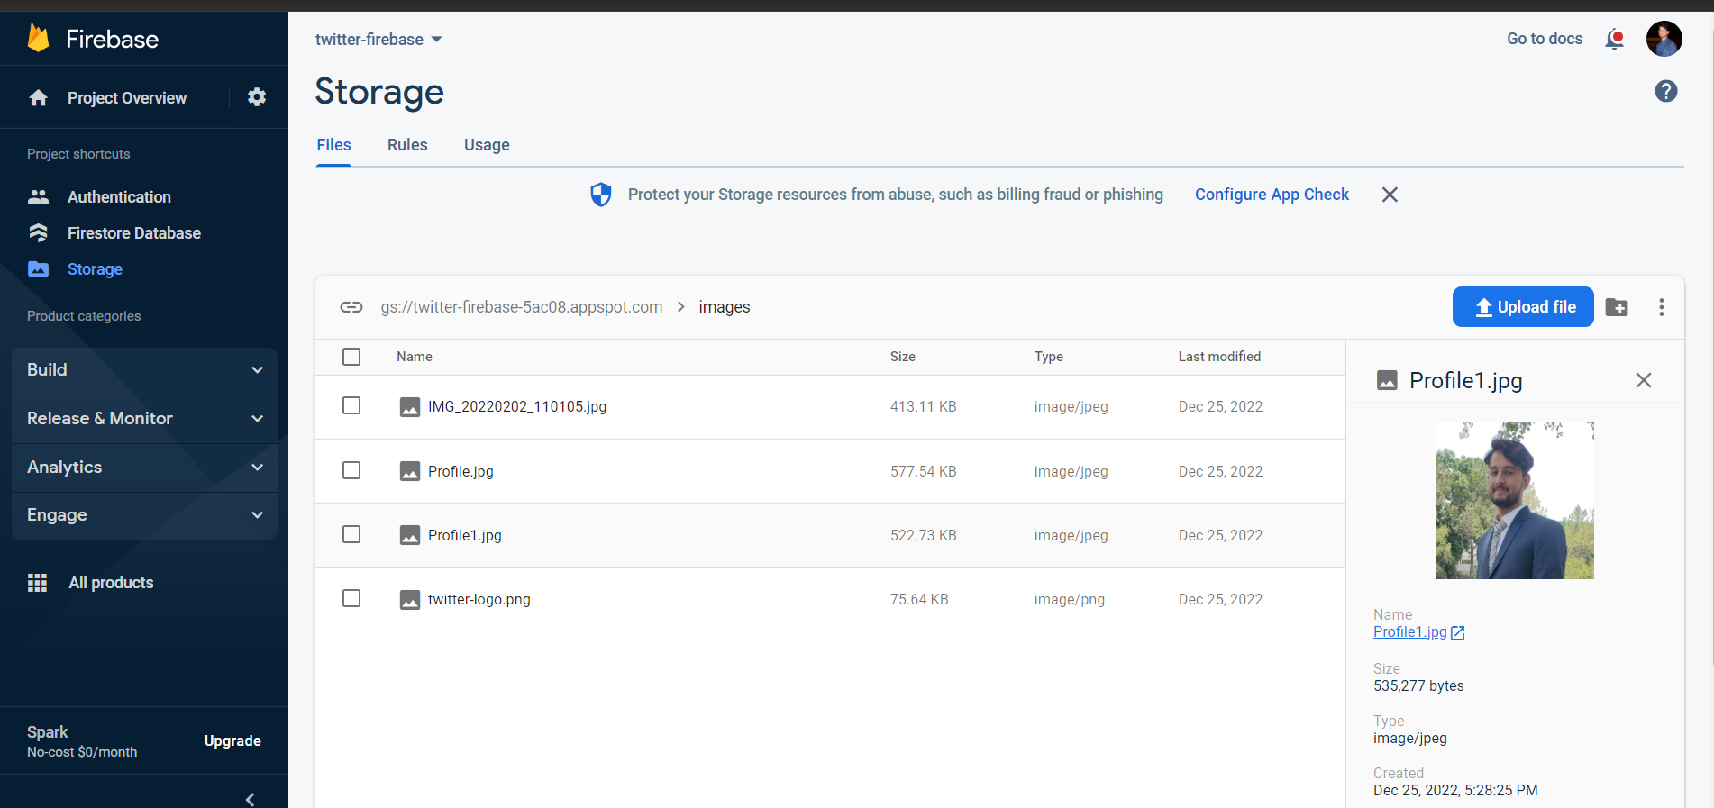

1. **Store data using mongodb/firebase/mysql**

1. **Display Web interface modern UI**

The Registered/authenticated user can login and see the registered users and their data.

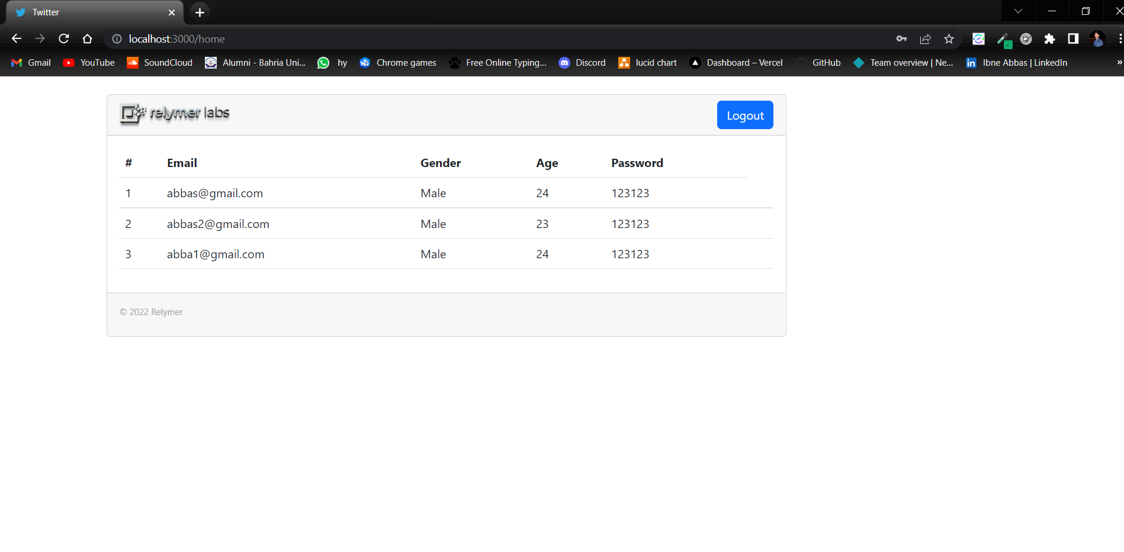

* **I have done the authentication using Email and Password Because there was an error while authenticating with Twitter.**

